Rule: Support Reduction of Short-Term Memory Load
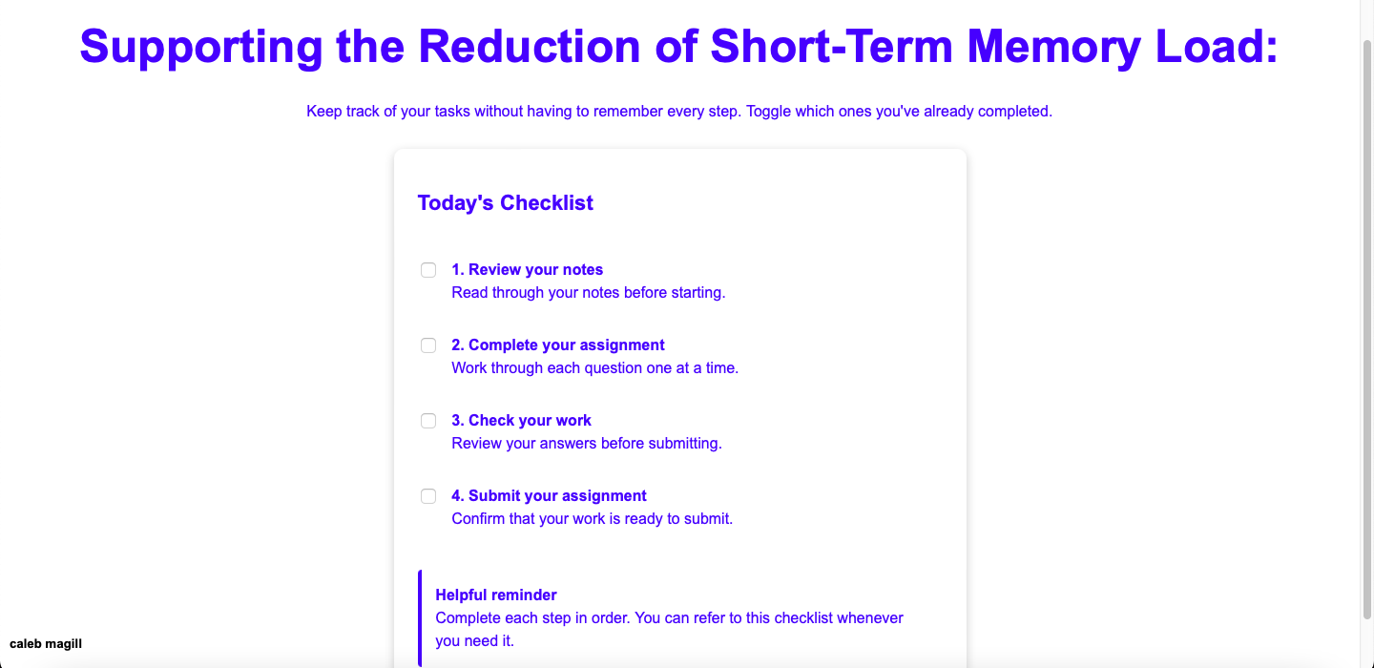
For this page, I took the approach of a tasks list; appearing as a checklist whereas the user can click which tasks they’ve already completed such to not have to recollect as to what has yet to be done. This supports the short-term memory of the user as they can be reminded what has still to be complete, being able to refer to the checklist at any point to remind themselves. Having checked a given task, the user can see clearly it is marked off, thus indicating they no longer have to recollect its completion. With the previous point, it additionally permits the reversal of actions, as a user may uncheck a given completed task. Additionally, as for further assistance to the user, a reminder at the bottom of the page is featured such to give informative dialogue to the user as to the nature of the page; that of course they can use it for future reference in the completion of a task.

